Nested Queries

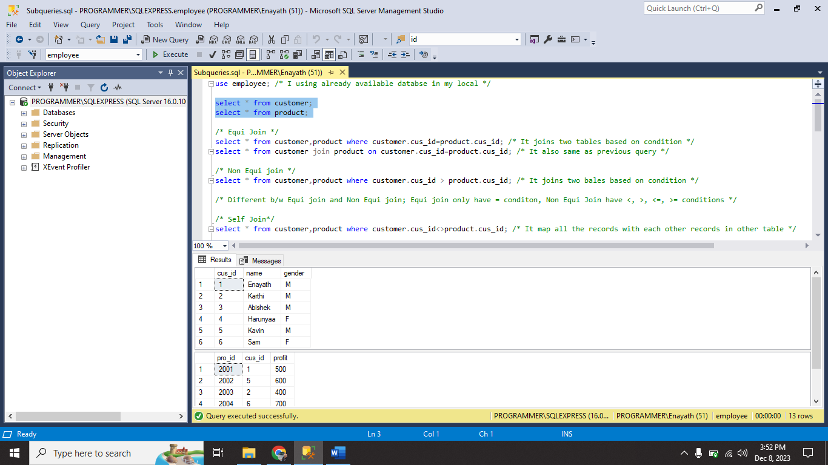

I used already available database **employee** in my local.

I used **Equi join , Non Equi join** and **Self join.**

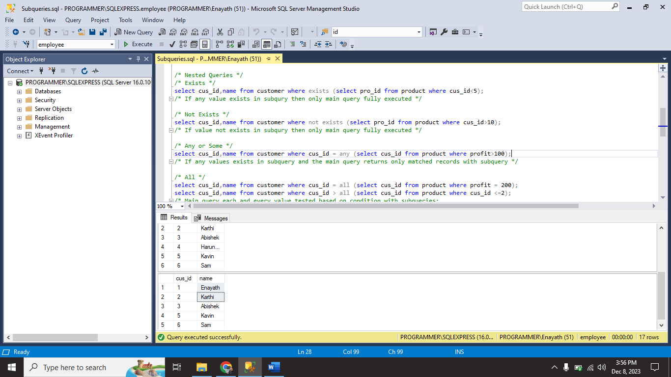

I used **EXISTS,NOT EXISTS, ANY/SOME** and **ALL.**

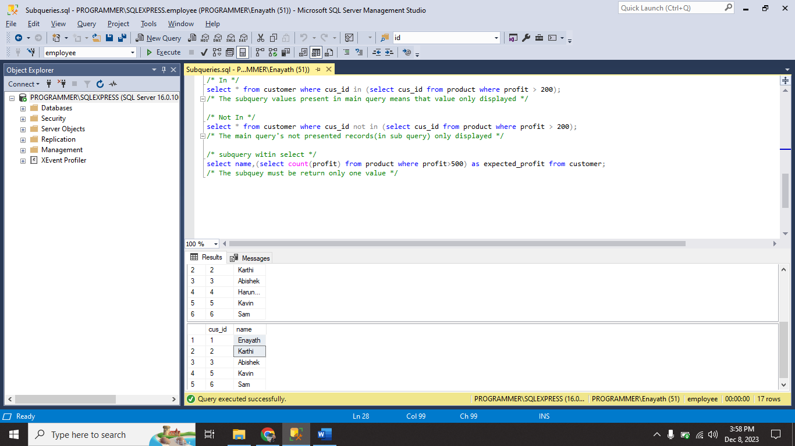

I used **IN** and **NOT IN.**

And also subquery within select statement.

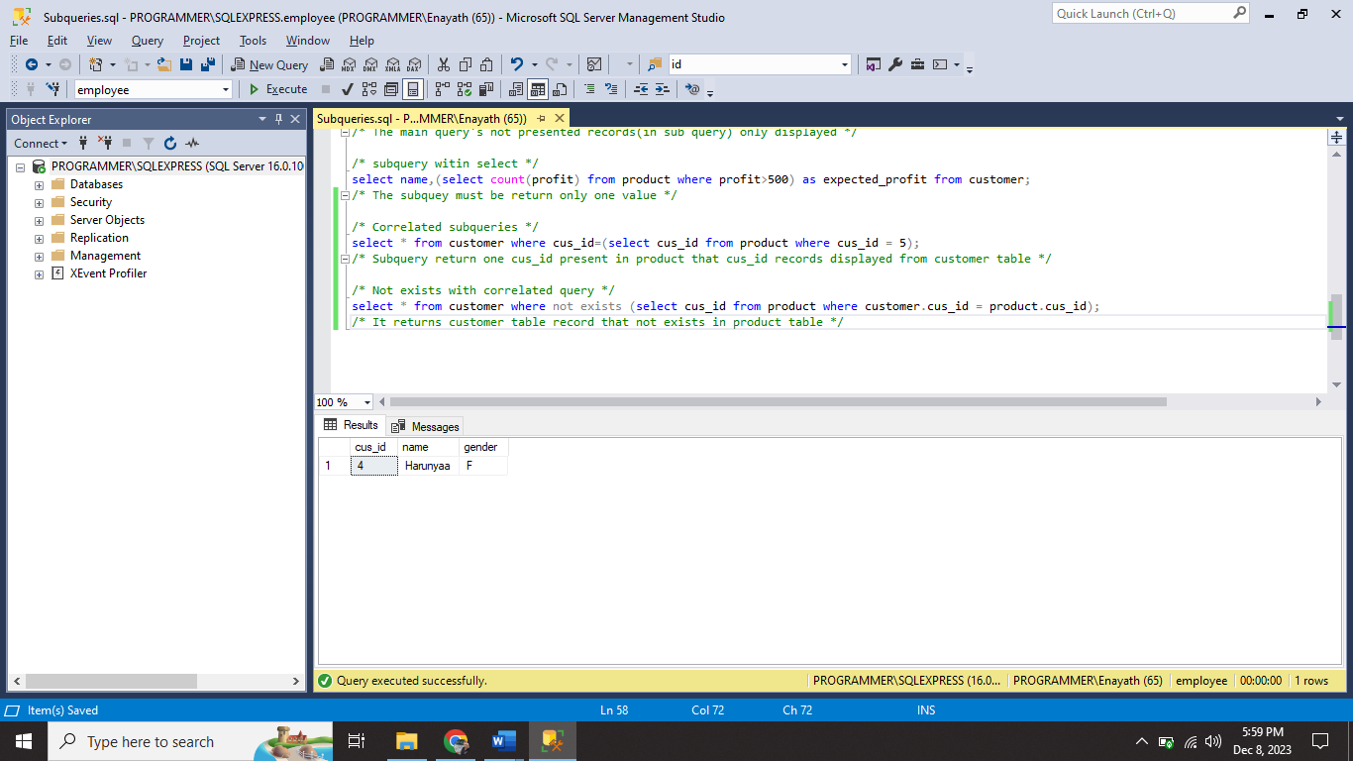

I used correlated queries. And also I used **NOT EXISTS** with correlated query.